API Test

**Steps to Run Collection :**

1. Download or clone collection from github url
2. Import collection to Postman and run it

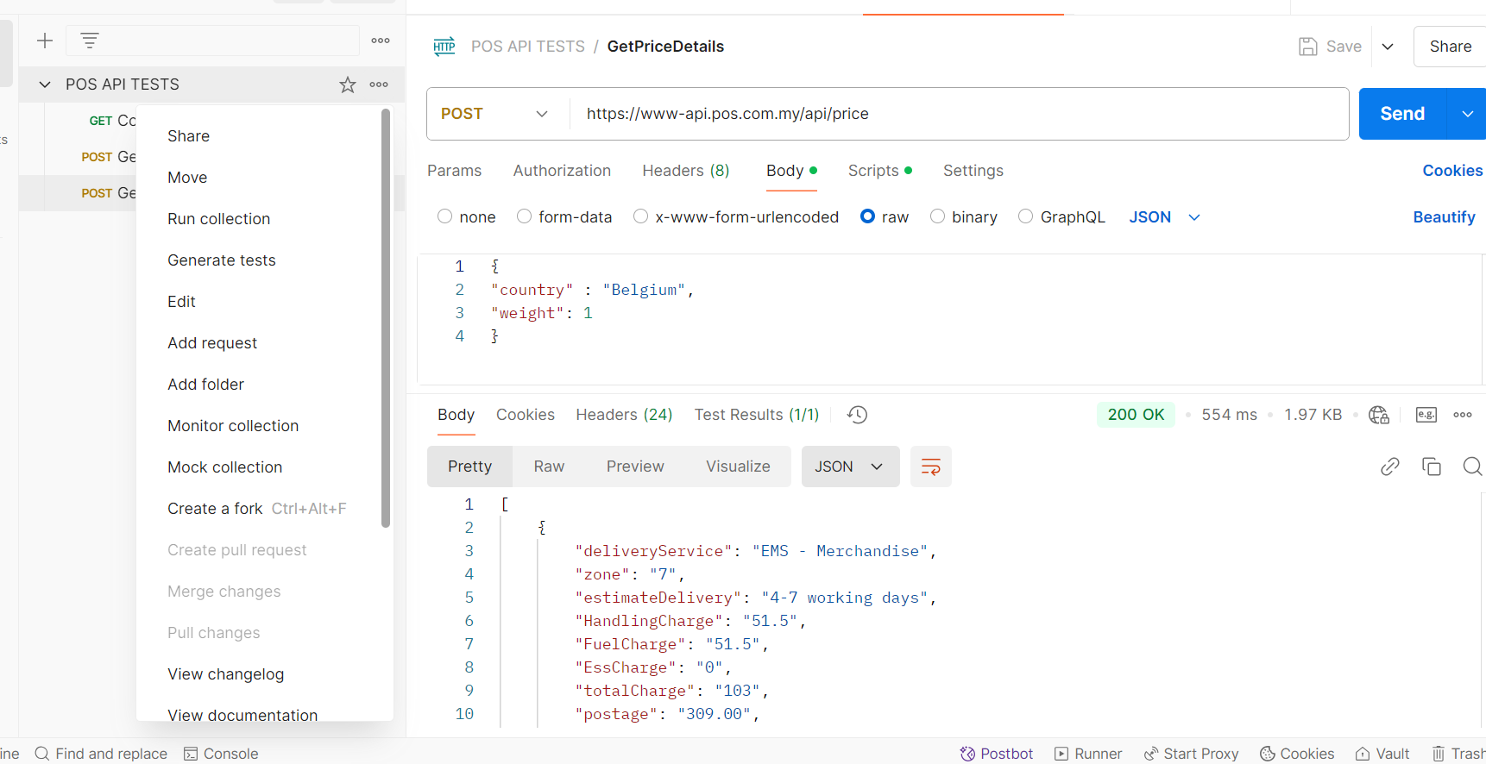

1. After successful run the response would look like this

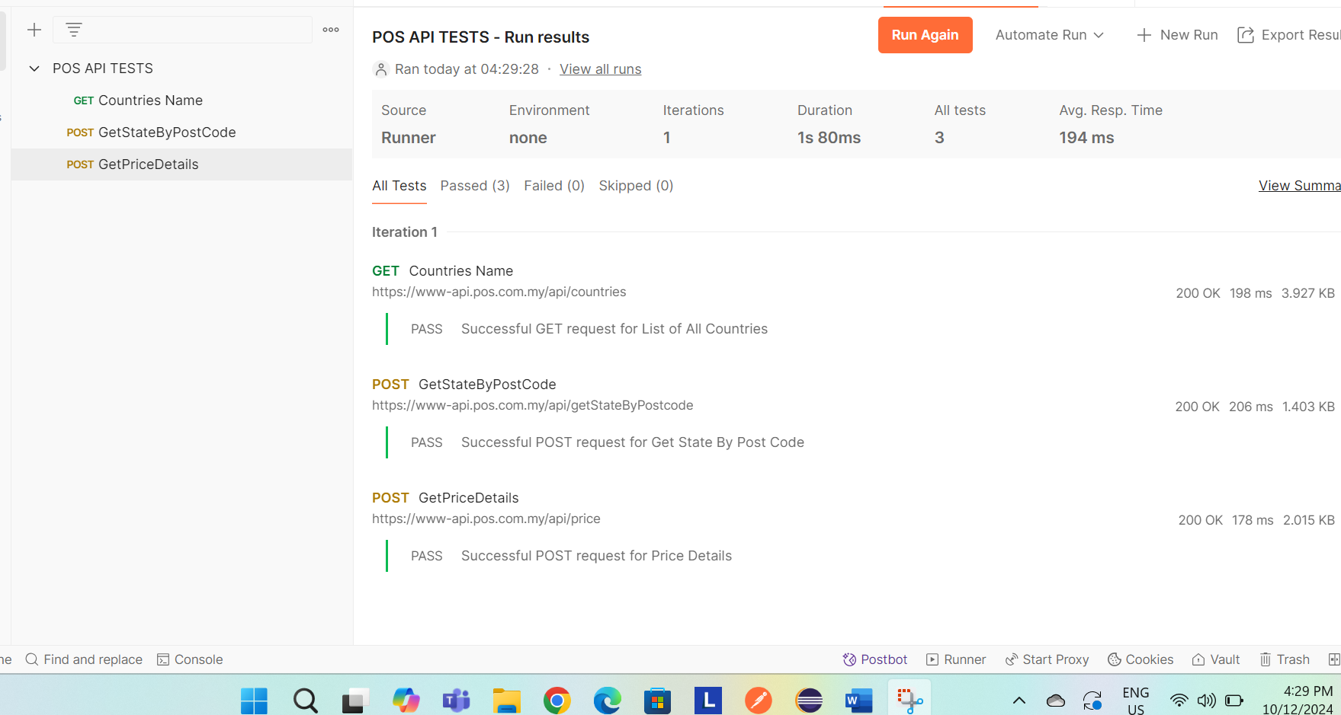

**Explanation of Each API’s**

1. GET countries

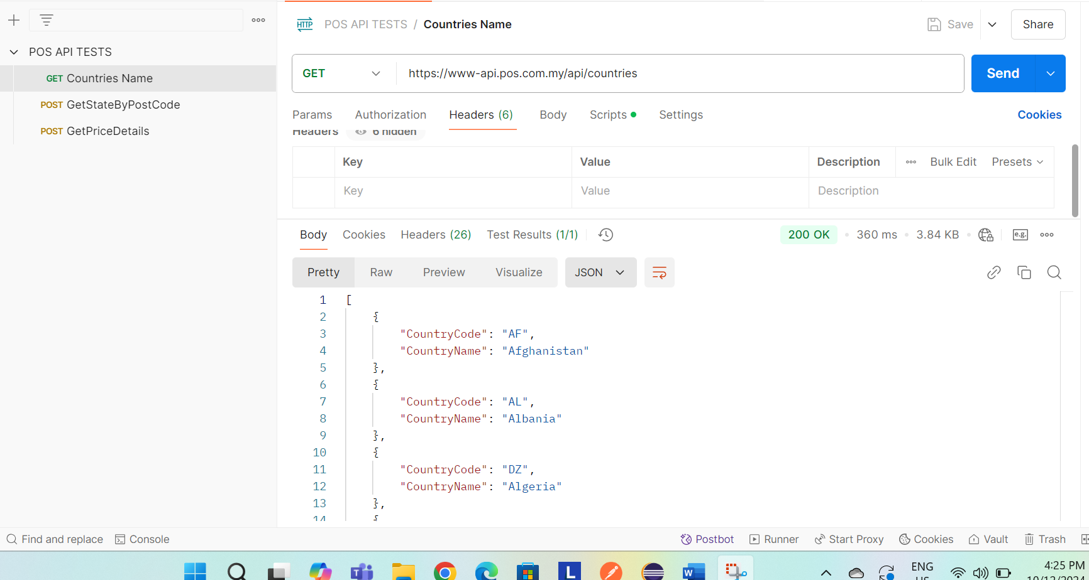

1. GetStateByPostcode

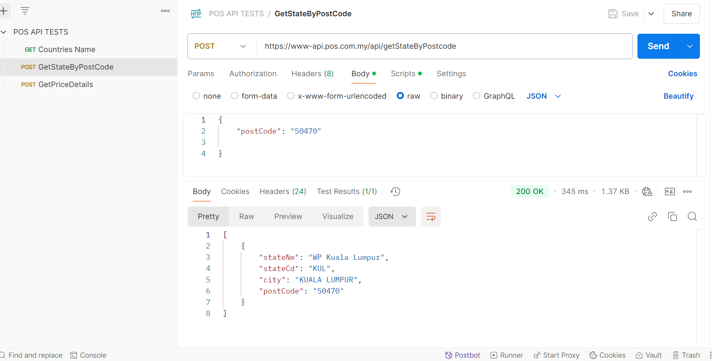

1. Get Price Details

